PROJECT REPORT TEMPLEATE

JOB APPLICATION TRACKING SYSTEM

TEAM ID: NM2023TMID18327

1.INTRODUCTION

1.1 Overview:

An applicant tracking system (ATS) is software for recruiters and employers to track candidates throughout the recruiting and hiring process.

1.2 Purpose:

An ATS allows recruiters to match job requisitions to the job-posting sites and the social media channels most appropriate for specific candidates.

An ATS also maximizes visibility for internal job boards, while requiring fewer clicks and eliminating barriers for prospective employees.

1. Problem Definition & Design Thinking

2.1 Empathy map:

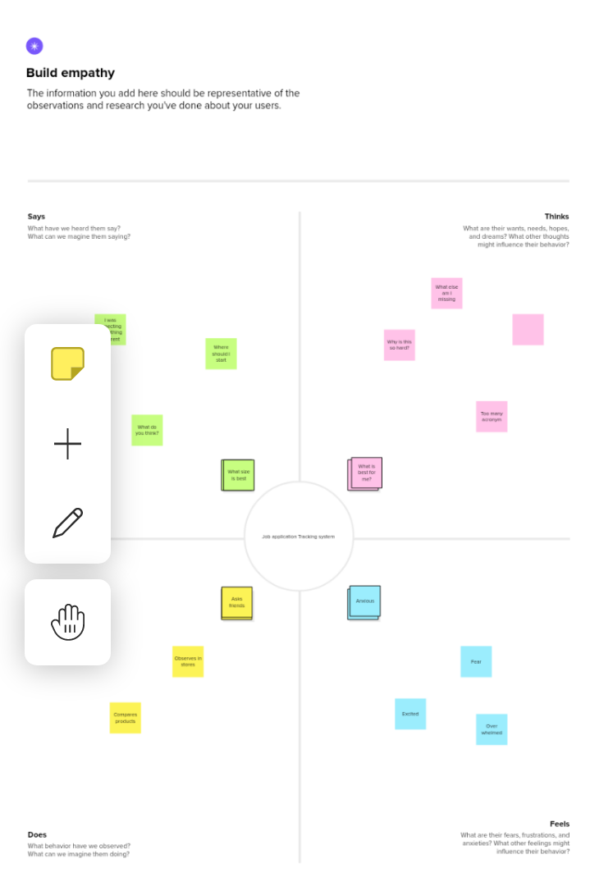

3.RESULT

3.1 Data Model:

|  |  |
| --- | --- |
| OBJECT NAME | FIELDS IN THE OBJECT |
| Job Application Object | Job application object name |
|  | Created by |
| Last modified by |
| owner |

3.2 Activity & Screenshot:

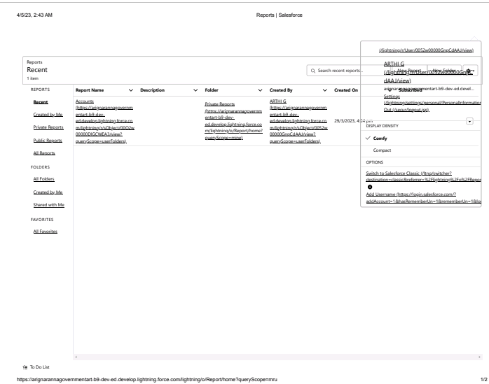

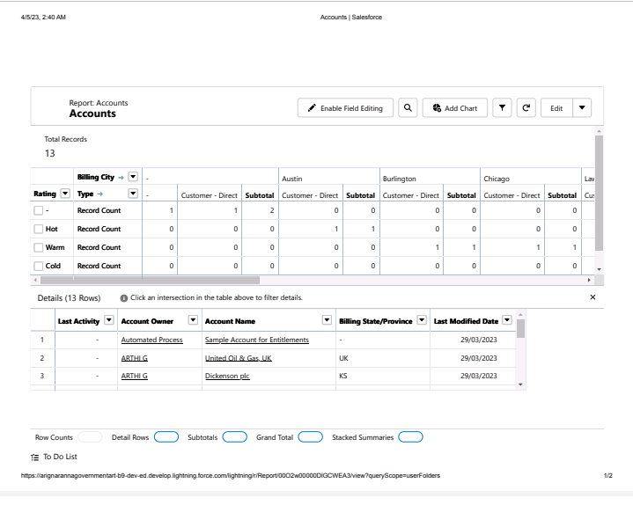

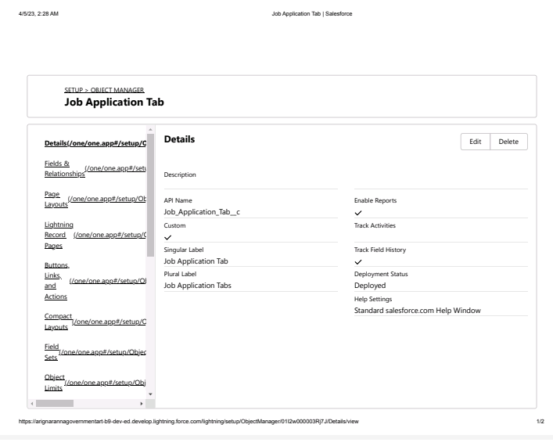

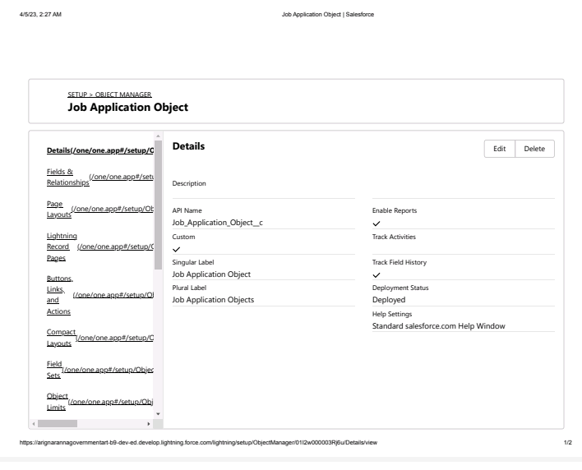

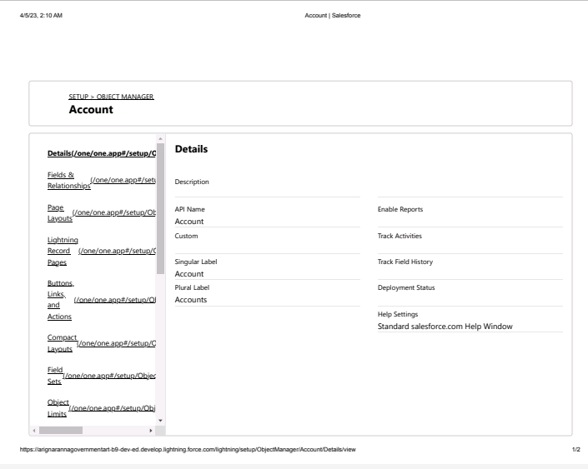

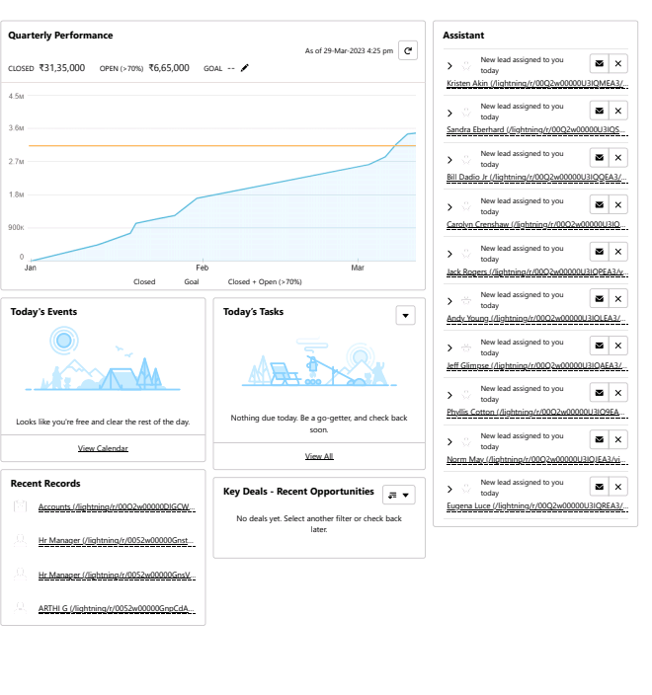

4.TRIALHEAD PROFILE PUBLIC URL

Team Leader - https://trailblazer.me/id/arthg5

Team Member1- https://trailblazer.me/id/anbag2

Team Member2- https://trailblazer.me/id/akumar8332

Team Member3- https://trailblazer.me/id/arraj90

5.ADVANTAGES & DISADVANTAGES

Advantages:

*Applicant tracking system advantages include enabling you to focus more on tasks that truly require your attention rather than spending manual resources on routine,mundane tasks.

*Good ATS can save almost 50% of your time by automating these routine tasks. Your processes get more efficient an faster.

Disadvantages:

*A disadvantages of ATS is missing qualified applicants due to wrong keyword selection.

*Automatic elimination of resumes that software cannot recognize and interpret is another drawback of ATS.

6.APPLICATIONS

An applicant tracking system (ATS) helps companies organize canidates for hiring and recruitment purposes. These systems allow business to collect information, organize prospects based on experienceand skill set, an filter applicants.

7.CONCLUSION

The tracking system performs successfully and further work would be required to implement it as a commercial quality and commodity product.

8.FUTURE SCOPE

The projects has a very vast scope in future.